**LAB 05:**

Ex1:

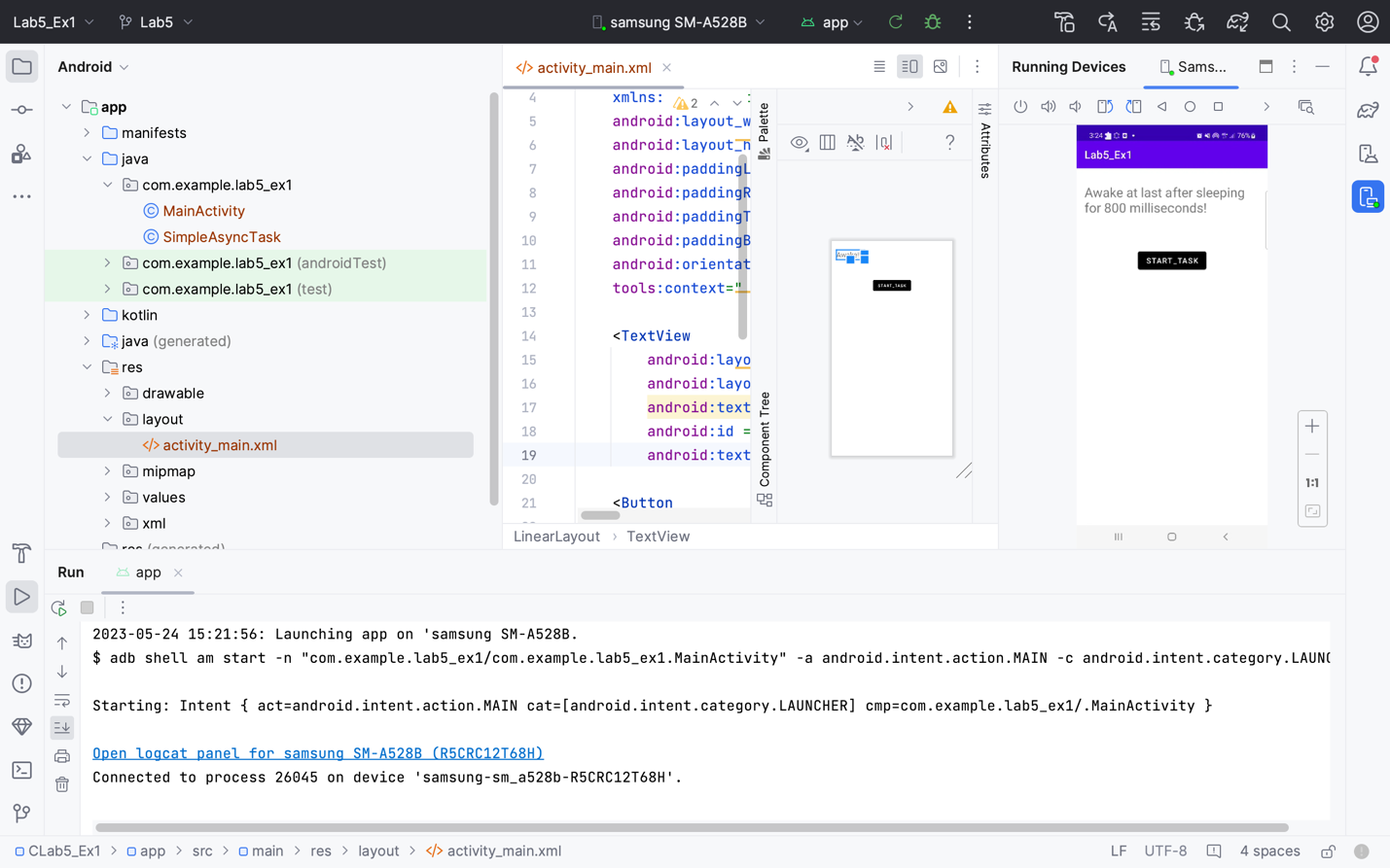

Ex2:

